Preliminary: once you have access to Lark, follow these steps to access TCS. TCS will always be your n.1 priority

You can download TCS using this link:
https://tcs-sg.bytelemon.com/worktable/download
Once you're in TCS, you should have access to 2 "queues" where TT uploads videos on a regular basis.
In order to find them, you have to type in the TCS browser EITHER the code OR the name of each queue, which are the following:
Misleading FC-BG (code 7226886535897989634)
General Misleading FC-BG (7226886558509433346)
Once you see the queues, you can bookmark them by clicking on the little heart on the left. Then every time you open your TCS homepage you'll see the 2 boxes.
All these steps are listed and illustrated in the attached PDF (TikTok Fact-Checker Onboarding Training)
You'll see all the tips you need for working on TCS in the same PDF

Now you can start working following this workflow (skip #2- #5 until you have access to Lark and TCS)
1. Login in the tt-Bulgaria Slack channel

2. Check TCS to see if there are videos. Note: TCS works only on PC, not on mobile.

3. Remember to start your work on your personal spreadsheet, where you'll keep a record of your work. You will add an English translation of your notes to your personal spreadsheet. On TCS you will write the claim in English and the notes in Bulgarian. In order to determine whether the claim is "top" "known" or "new" check against this document (accessible only once you're logged in on Lark):
https://bytedance.us.feishu.cn/sheets/shtcnr2Q8mGAzt5T90CcMCtGksb

4. Once you have finished your fact-check, copy everything on TCS and click submit.

5. Keep refreshing TCS, the videos can appear anytime during your shift. I recommend flagging the "Stats auto refresh" option so you're always updated
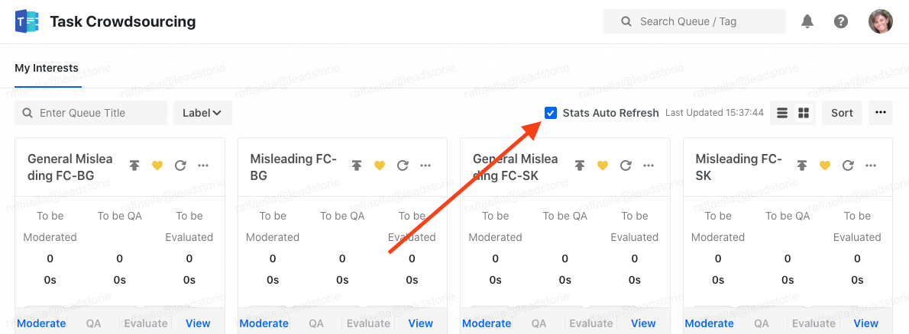
6. If there's nothing on TCS, you can start looking for trends. Attached is the handout guide I showed you during training (Handout Advanced Training Sept. 22). The format and other indications are in the Trends-tracking guide:
https://docs.google.com/presentation/d/1ogQmM5hro8vMtMG834l6SCgKXmvdU3QVVRHcQtC6Fdk/edit#slide=id.g1837bfb5454_0_5
7. Record your trends in your personal spreadsheet. If you find multiple videos for one claim, put them in the same row, like this:
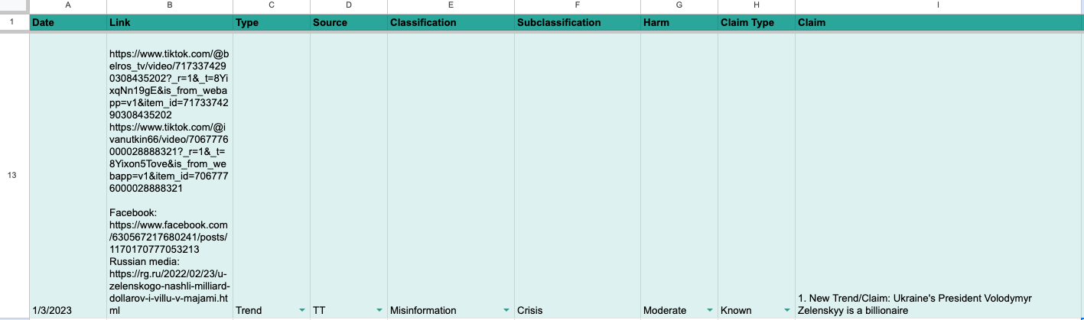
In this example, you'll see that the fact-checker added a Facebook link and some websites. That is useful too, although not compulsory. We're interested in knowing if the claim appeared on other platforms.
8. Send an email to Chelsea, Liana and me, following the format you'll find in the trend tracking guide: https://docs.google.com/presentation/d/1ogQmM5hro8vMtMG834l6SCgKXmvdU3QVVRHcQtC6Fdk/edit#slide=id.g120ce434fc0_1_54
Here's an example:
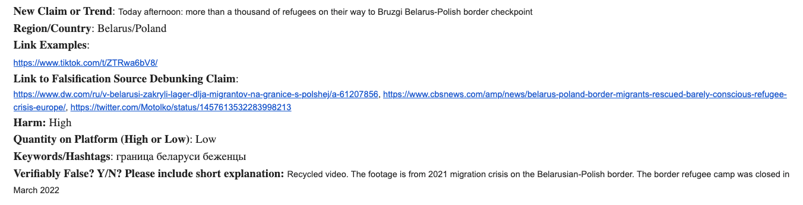

9. Go to the Trends tracker
https://docs.google.com/spreadsheets/d/1HkGoK8bJygnhRafWyY0UwjD6bzDjkG_ivE_1UFs9QBg/edit#gid=1386178329
and add your trend following these instructions:
https://docs.google.com/presentation/d/1wTShzkOdTWkoB6mGTTvTygw6RsQ6-ub6yV1VmH1XQXs/edit#slide=id.g12c2f344cc4_0_20
Attached is a short video that simulates the process (shortvidontrendtracker)

10. We'll look at the trends and will ask you (via email) to work on one or more for a short story.

11. Write the story on the Bulgarian Movable Type. When it’s ready to be edited, send a message on the tt-Bulgaria-editrolls Slack channel following this template: RFE/name/headline. One of the editors will get in touch with you in case of questions/doubts etc. Please keep all the communication related to an individual story to the same thread started with the RFE message, or in DMs with the editor, so the channel doesn’t get clogged with messages.

12. When your shift is over, check out on the tt-Bulgaria Slack channel

12. Go rest!

